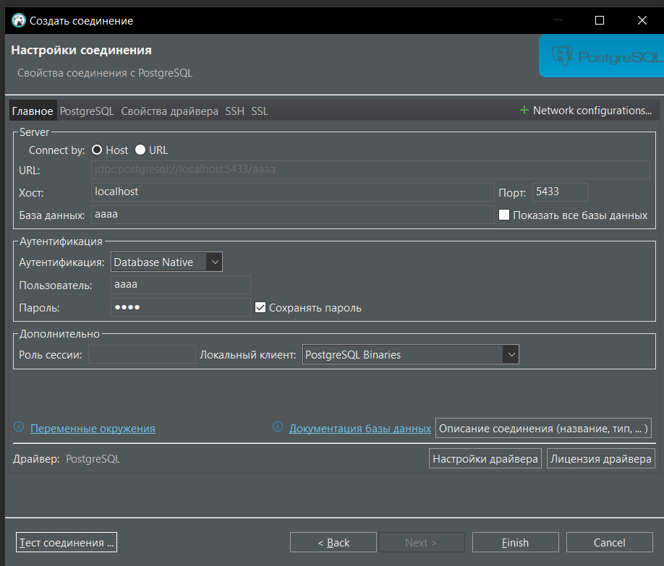

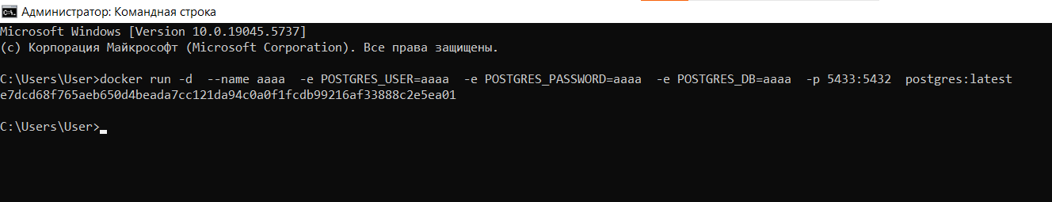

C:\Users\User>docker run -d --name aaaa -e POSTGRES_USER=aaaa -e POSTGRES_PASSWORD=aaaa -e POSTGRES_DB=aaaa -p 5433:5432 postgres:latest

e7dcd68f765aeb650d4beada7cc121da94c0a0f1fcdb99216af33888c2e5ea01